Ian Hoyos

CSC-423

Prof. Sayed

FINAL PROJECT DB

**DATABASE CREATION/POPULATION**

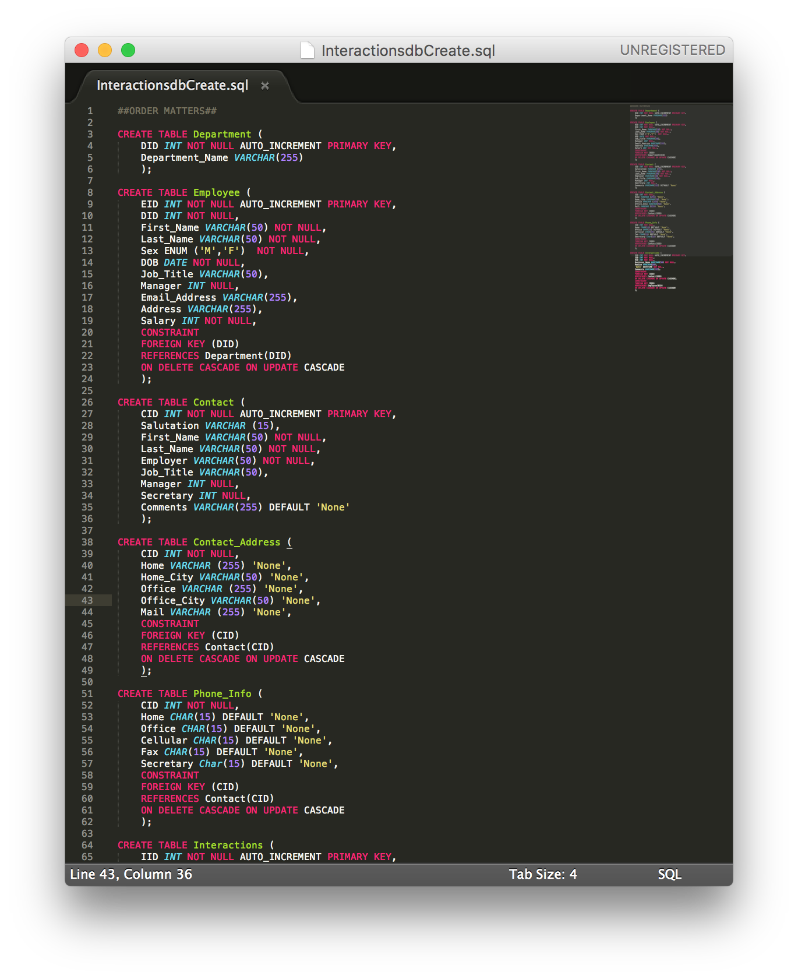**CREATE:**

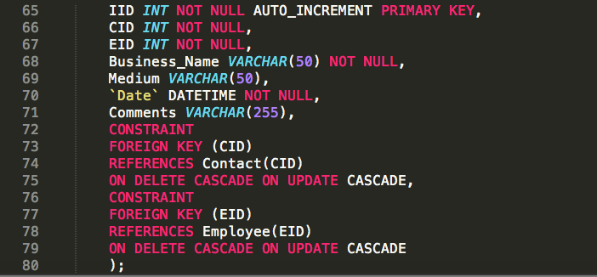

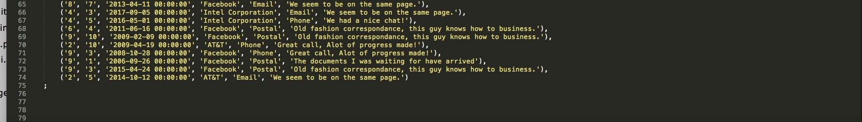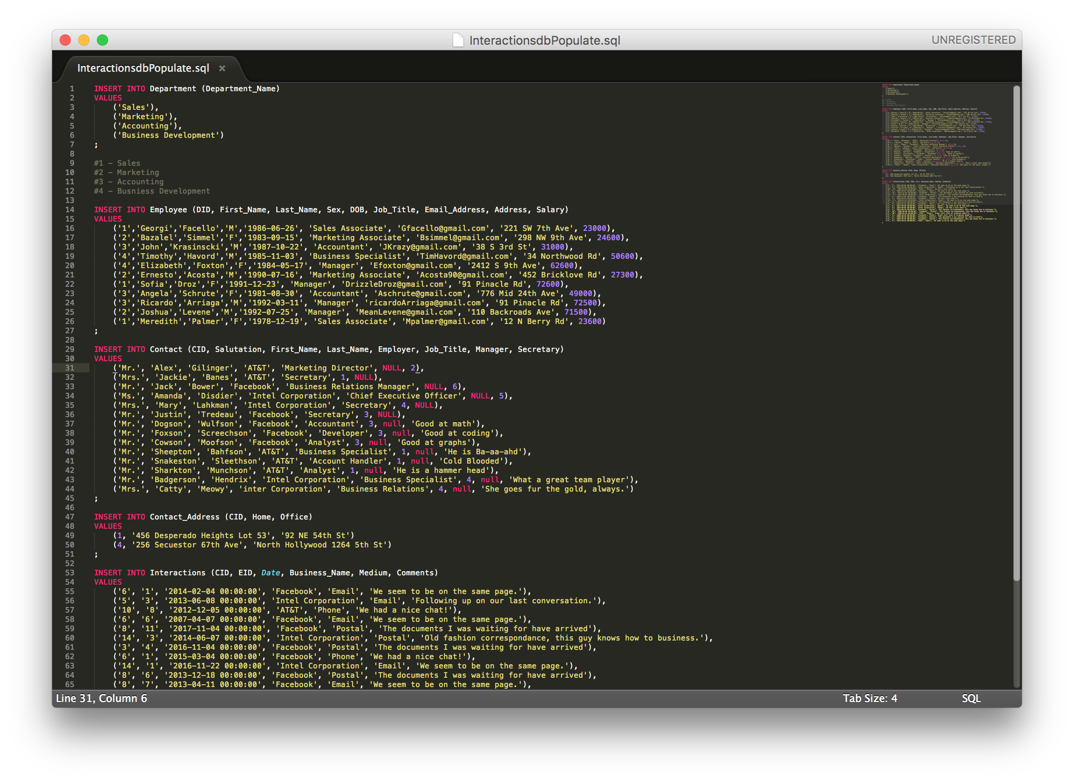**POPULATE:**

**Implementation Design:**

For my implementation, I deployed my DB on a web app I created through Django. I’ll Include as much of the project docs as possible, but it is a very large project with a lot of front end, back end, and middle-ware components so including it all into this doc would be excessive. I will, however, try to cover all the bases of the project implementation.

First, instead of making single queries to the database, I created form on the front end that handled input acquisition, and that data Is then used to send queries to the database. This turned out to be tedious because I had to account for scenarios where 1 or more optional data points were used by the user.

Secondly, Django uses models to handle the mid-way transition from the database to the logic component that conducts any processing that may need to be done. Models are python-Django equivalents to SQL ‘create statements’, they declare fields for every attribute, per table, per schema.

Thirdly, Django uses views to communicate data through to the user on the front end. Views in Django are also used for data processing and logic processing; it is the last stop before data goes onto the pages and the first stop when it’s coming back from the page. Django views are the equivalent of controllers in ASP.NET or other web app development platforms. Views are composed of classes that request data objects from the models, which then in turn requests data sets from the DB.

These are the basic components of the web app, obviously there are a lot more like templates, and table instantiations, static resources, URL definitions, etc.. but for the purposes of understanding the implementation of the DB into this project, these three are the key.

Below you will find screenshots of the code for each of the three components.

**Model:**

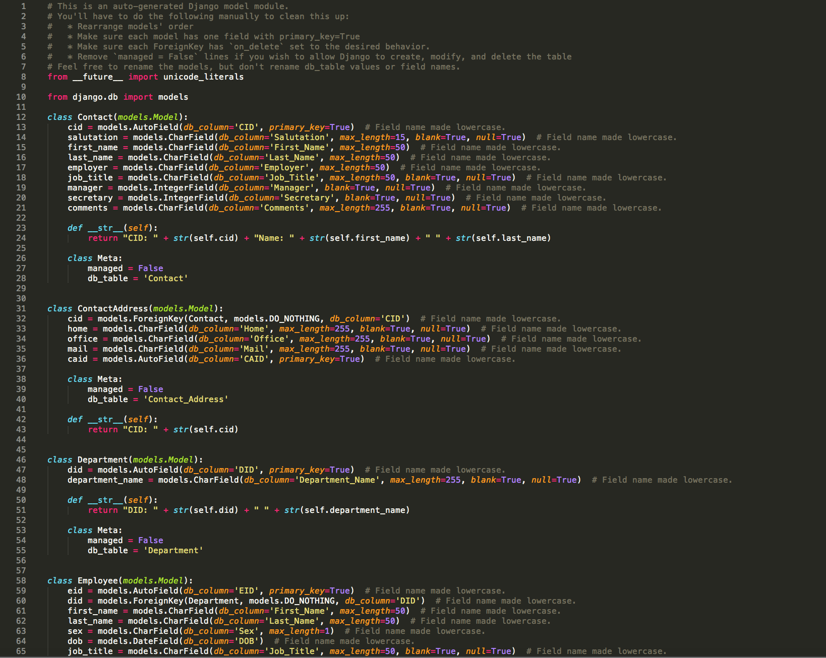

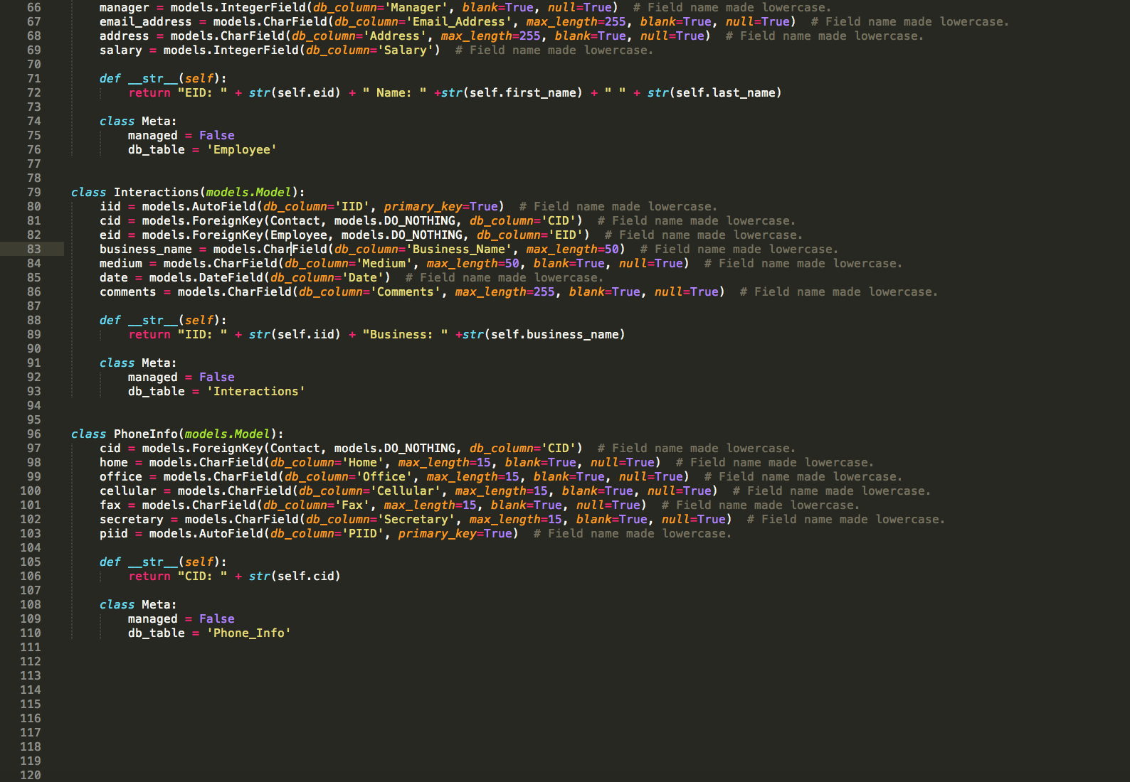

**Views:**

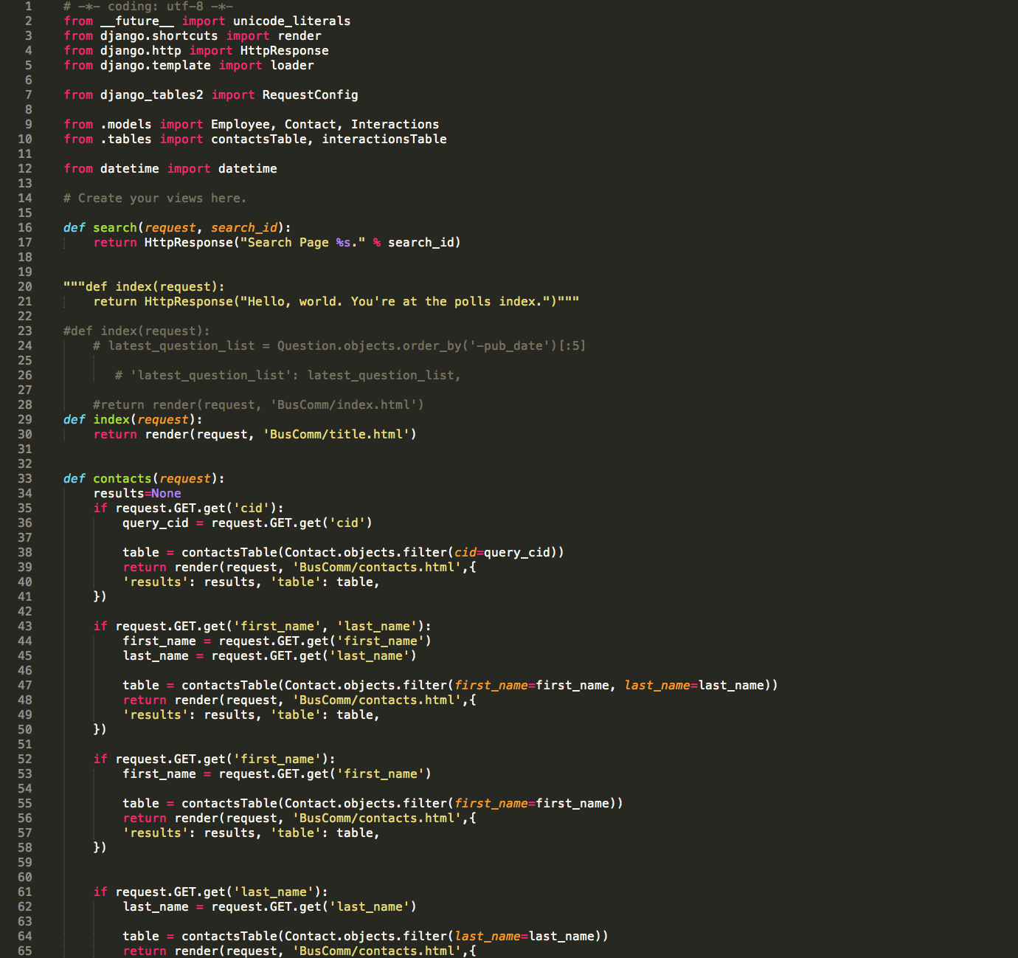

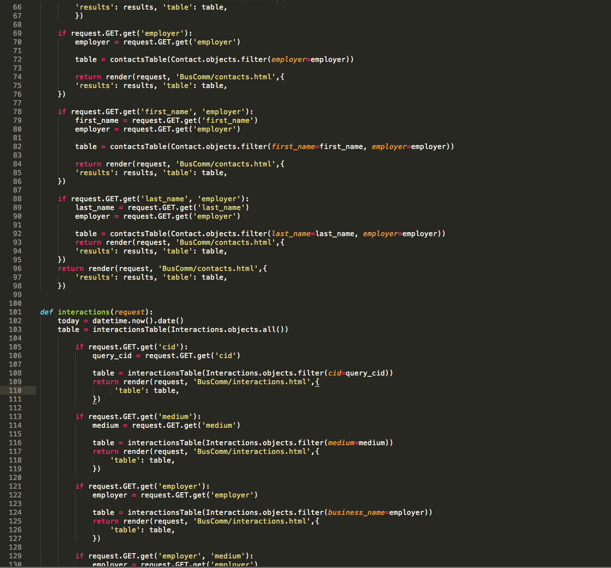

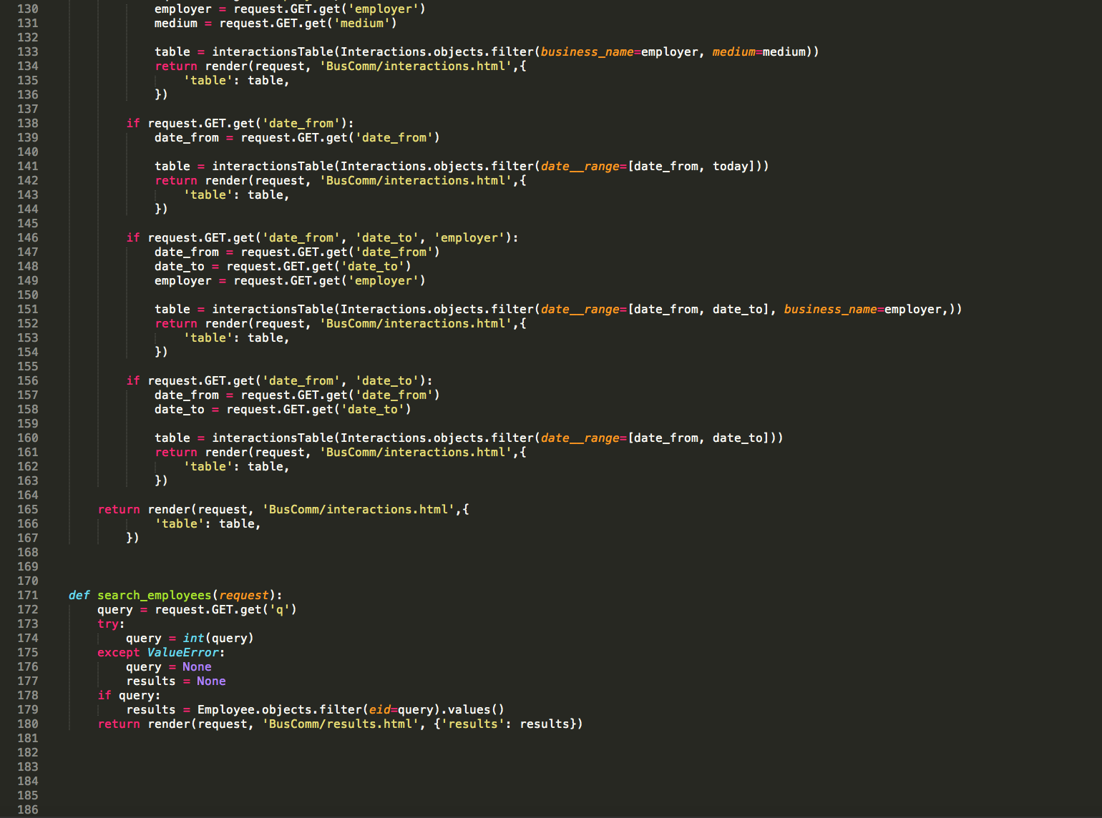

**Front – End Forms**

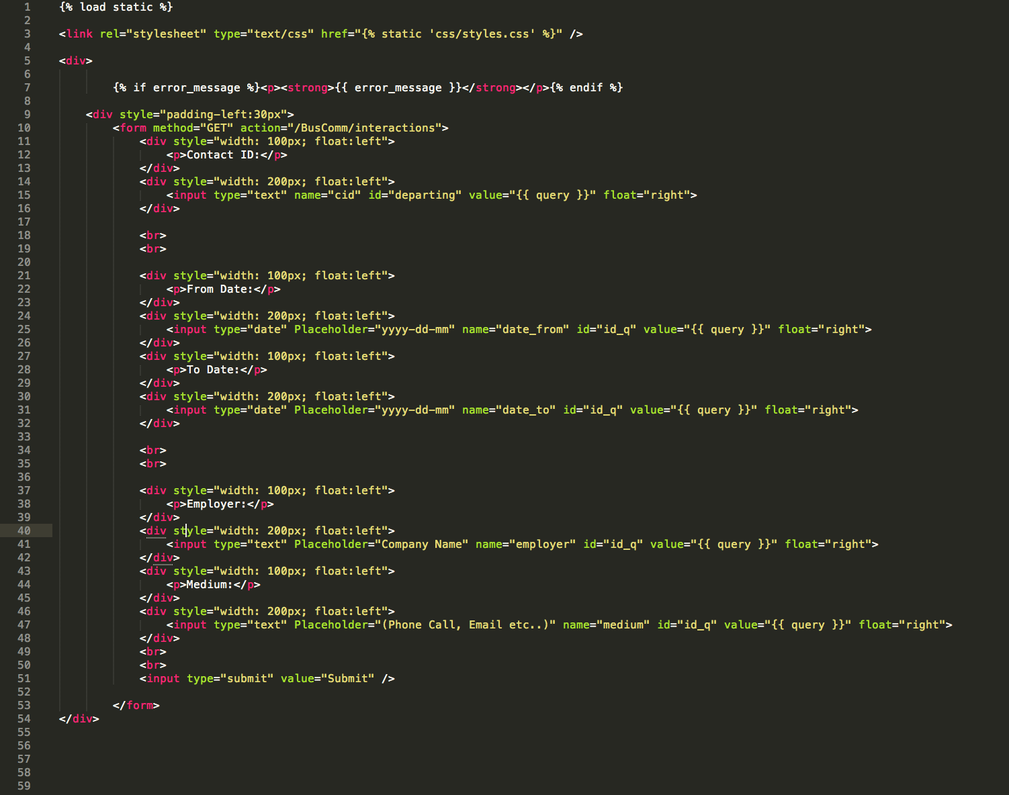

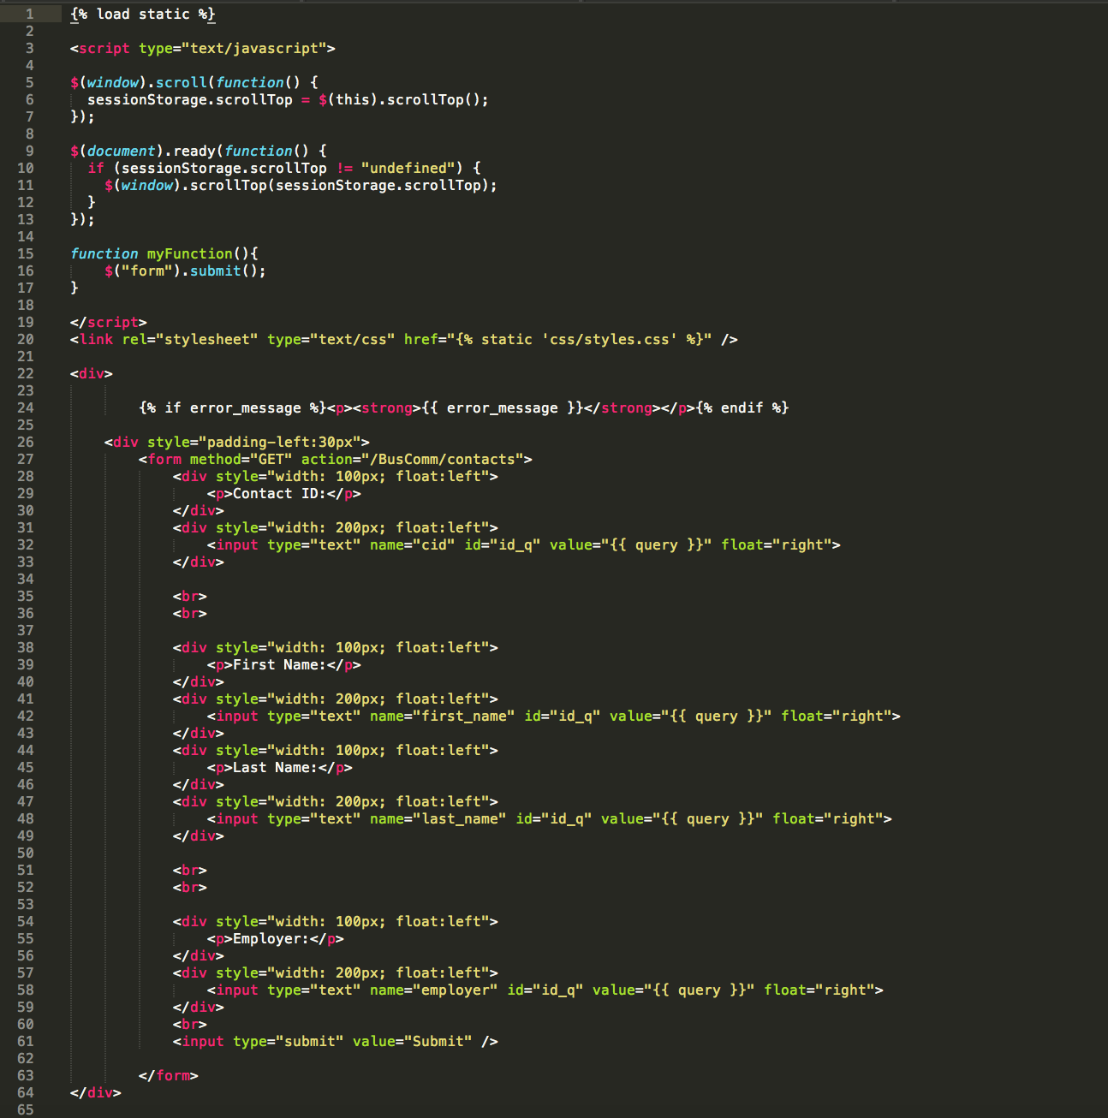

This is a test of what’s going on in the background of the site.  
  
Below you will find screenshots of the website Front-end, and how form submission handles queries to the data. The images will include several scenarios of how data can be, and gets looked up



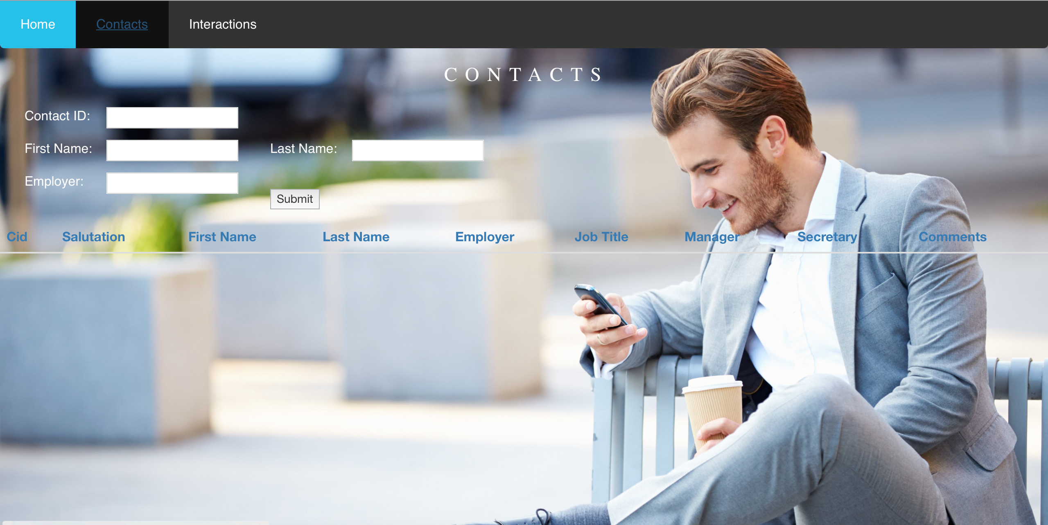

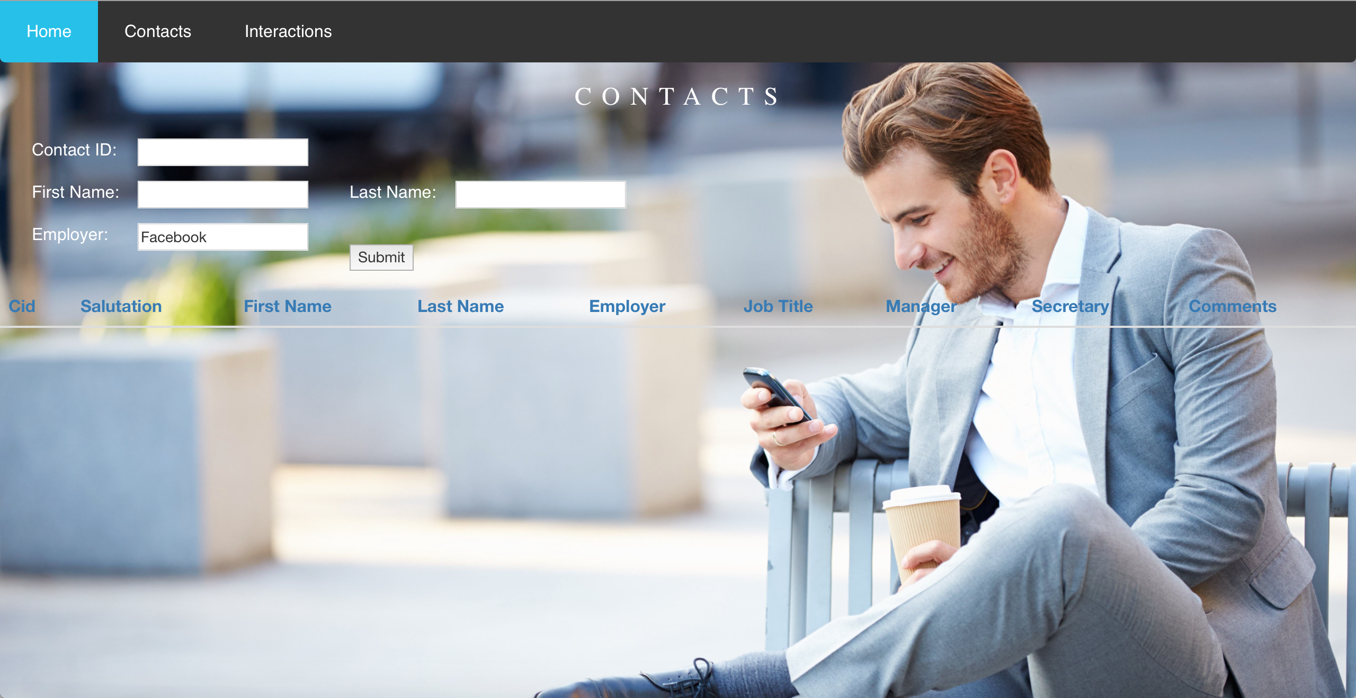

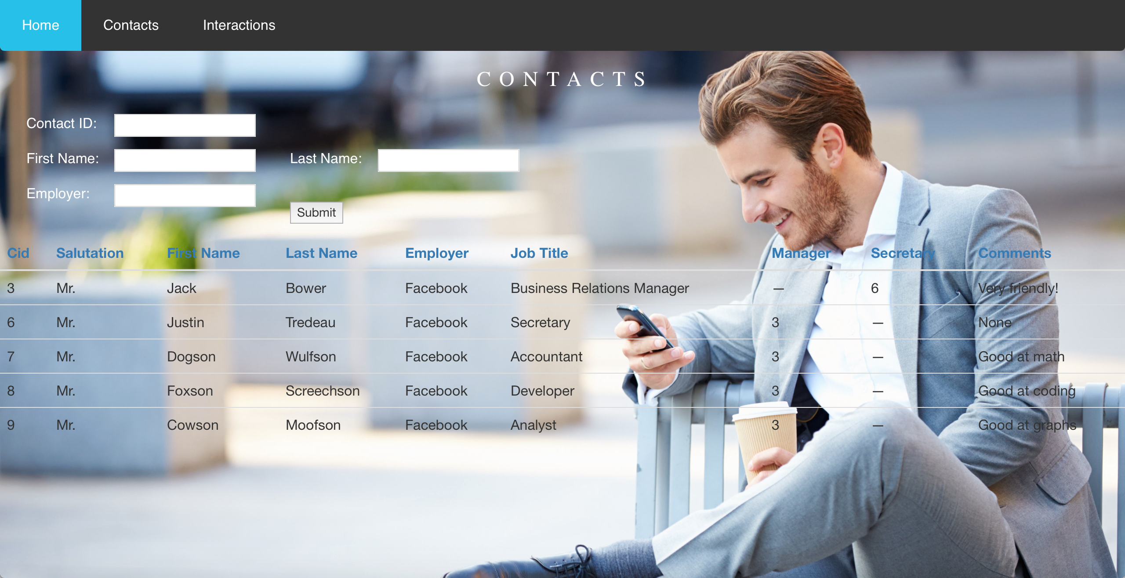

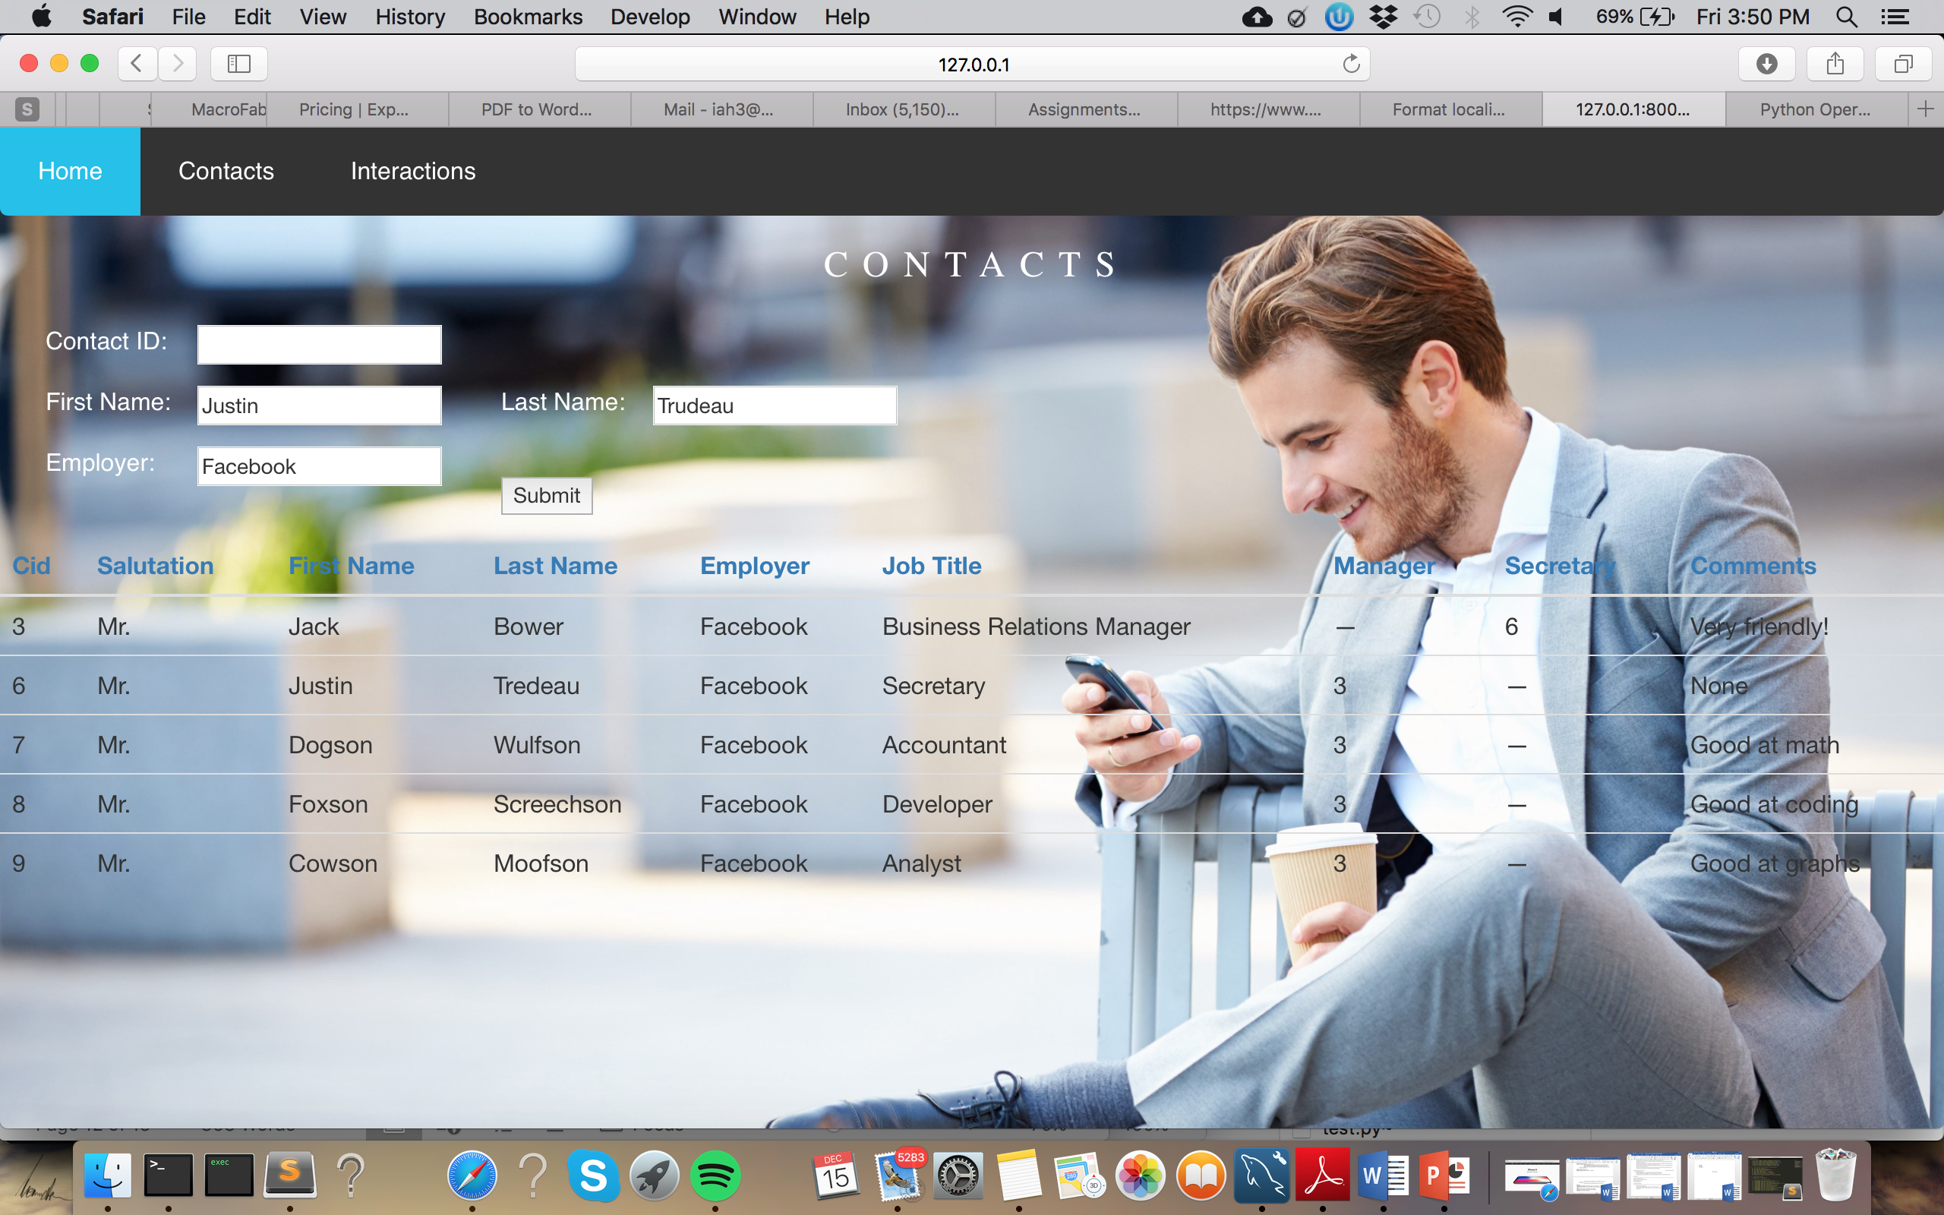

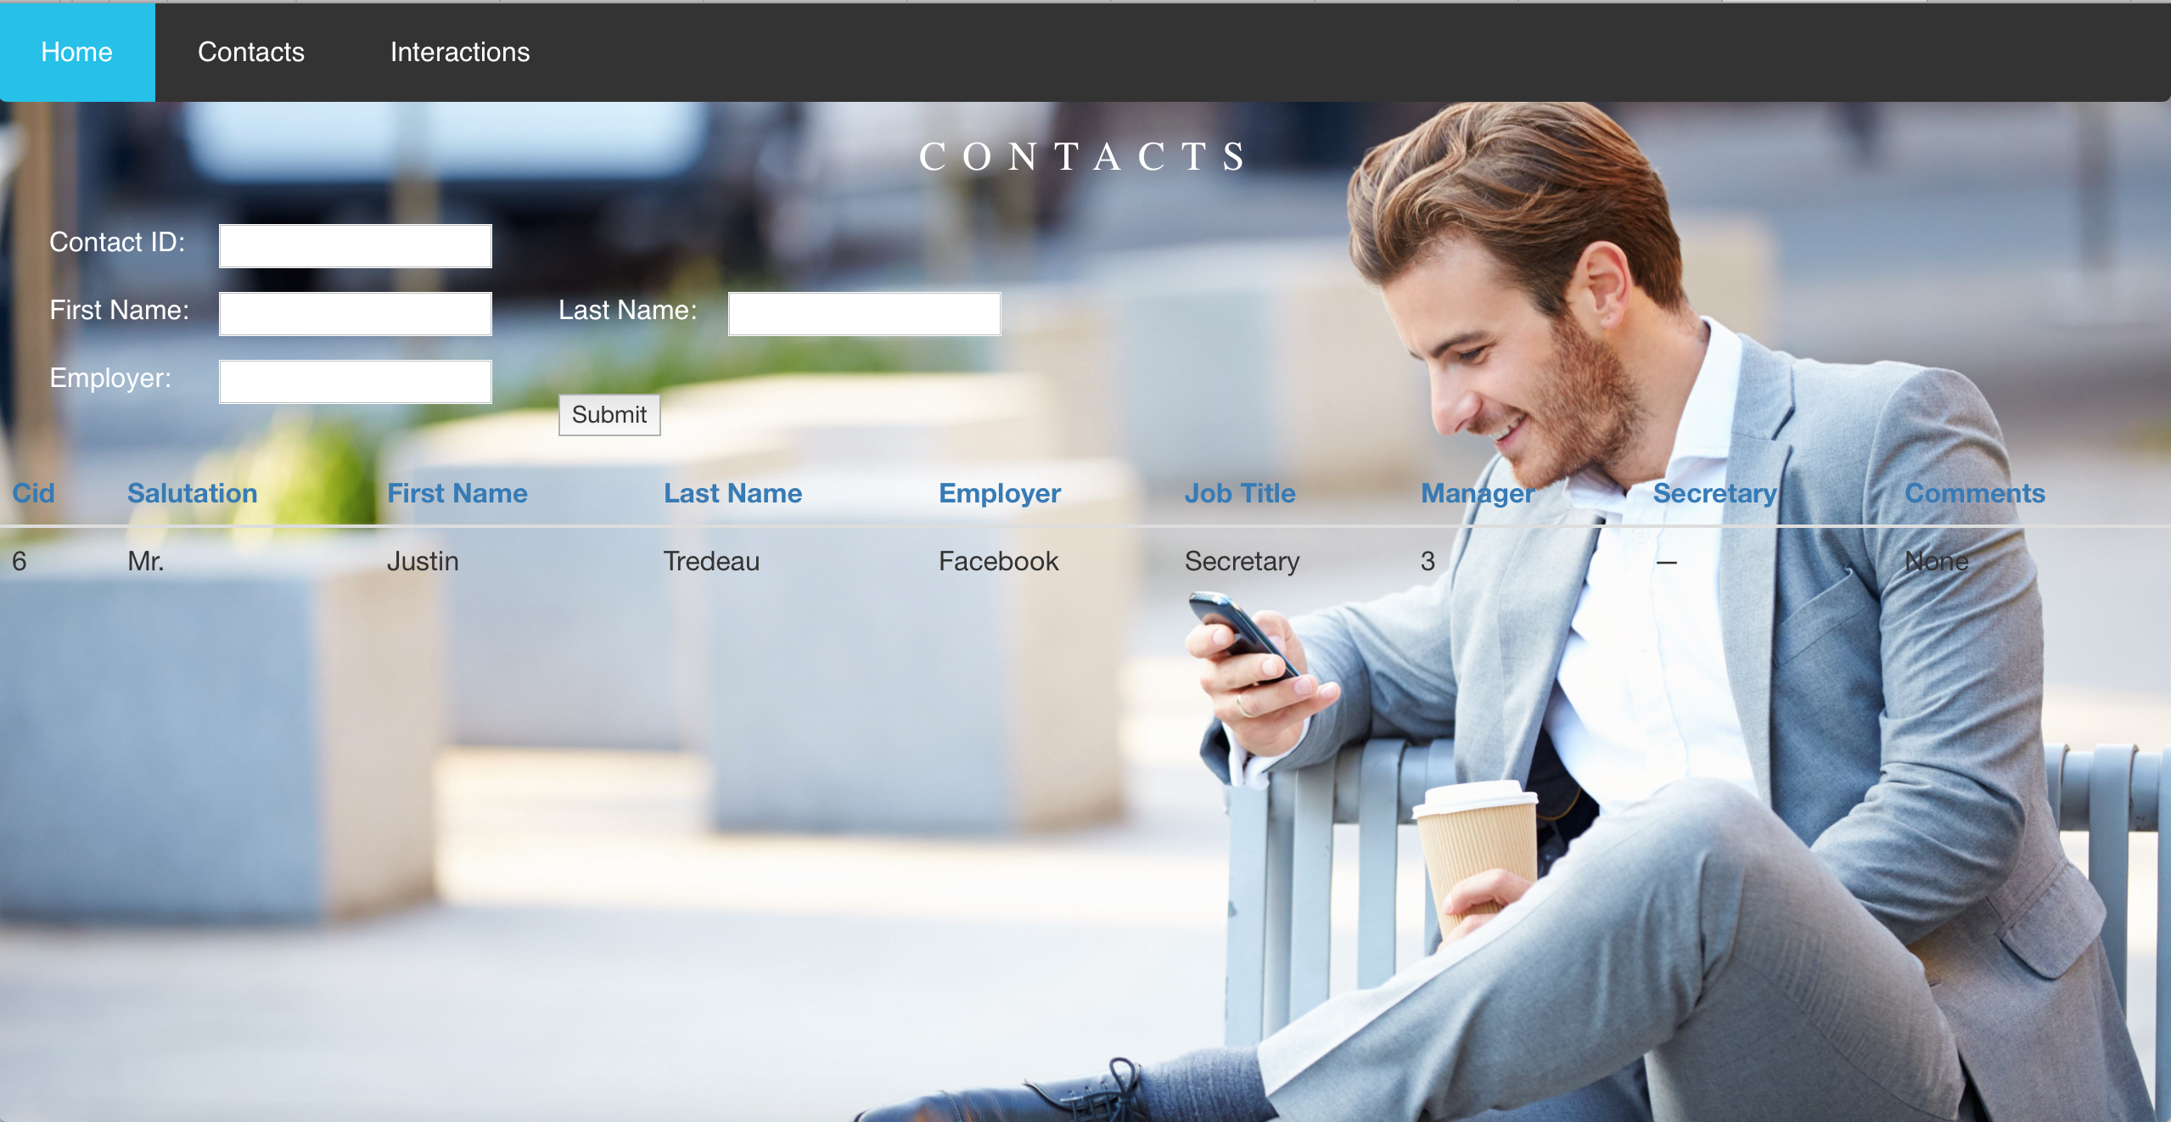

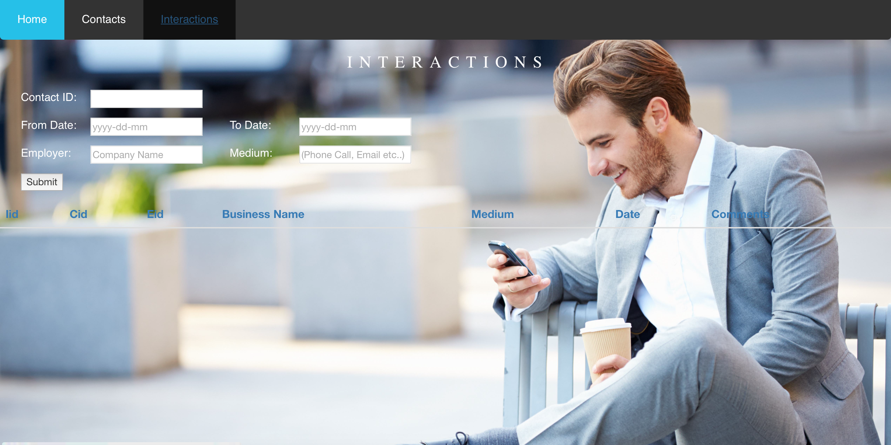

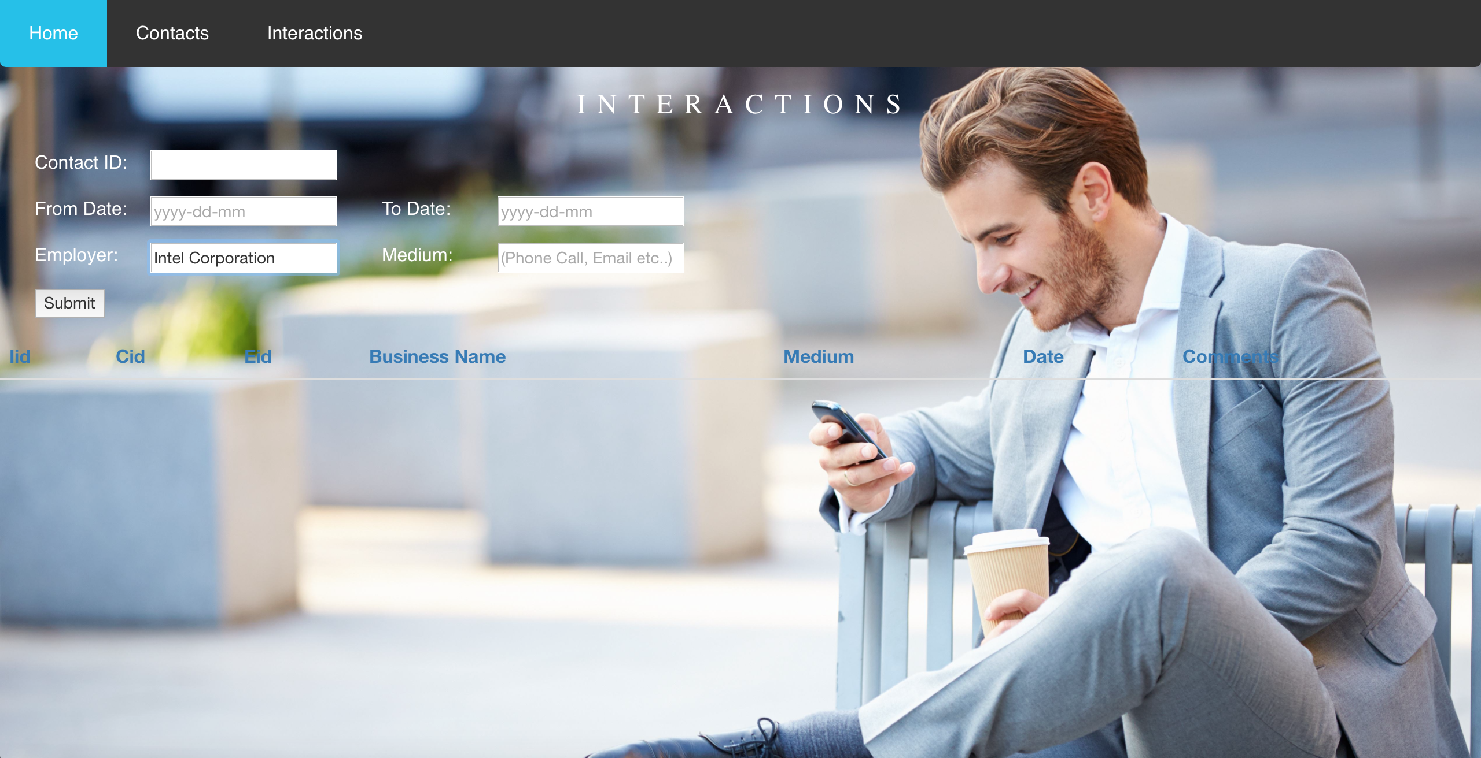

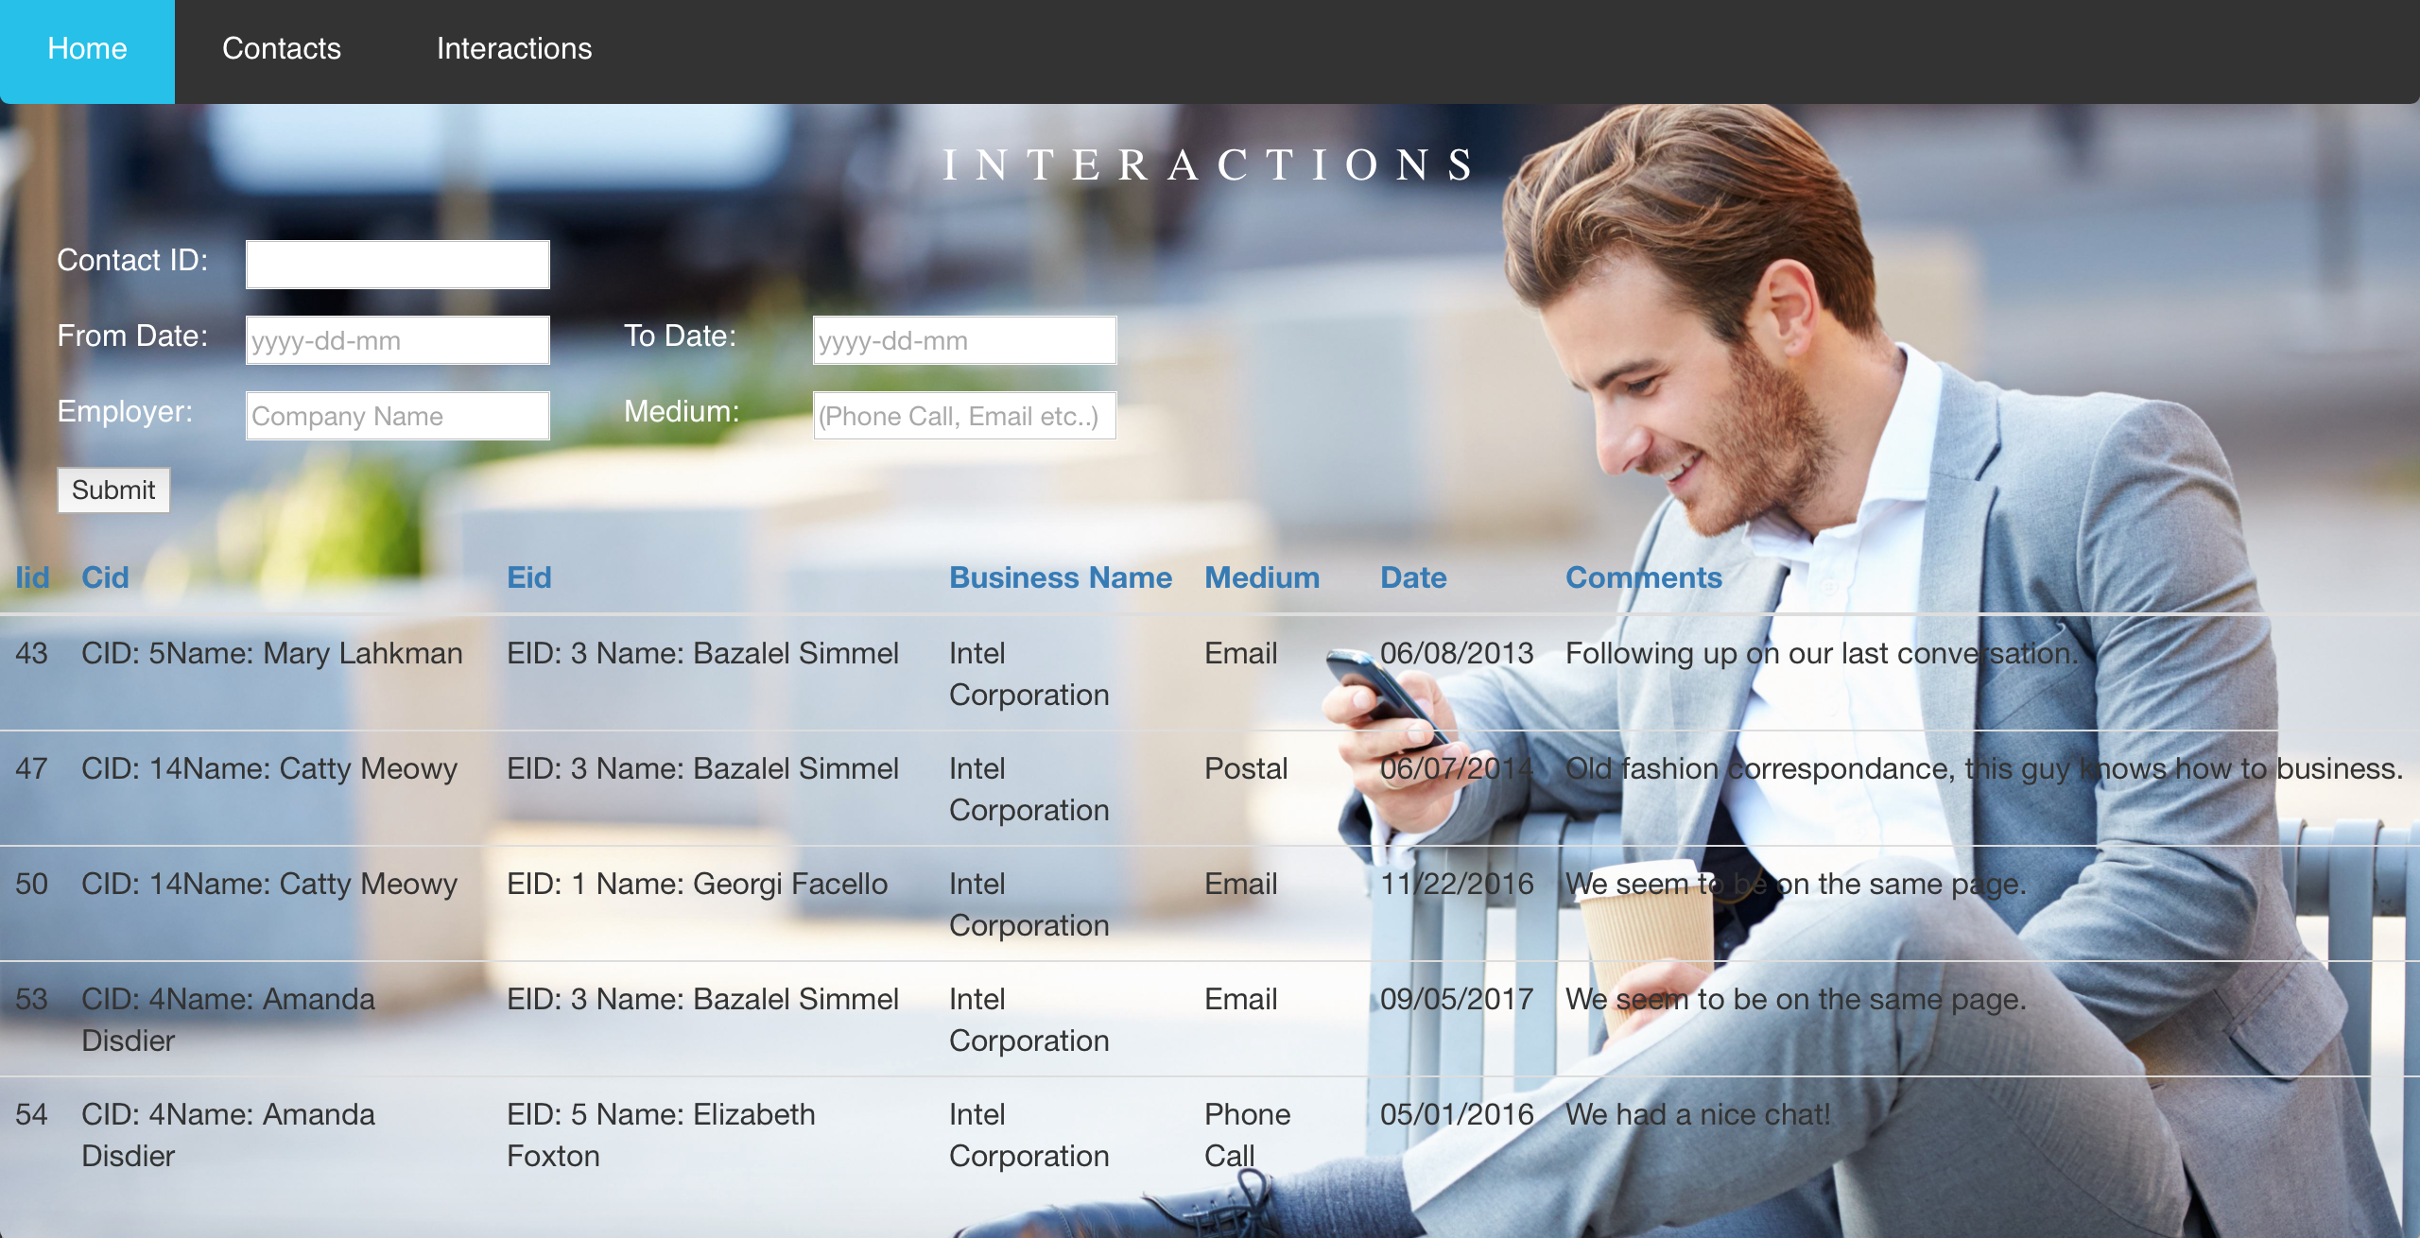

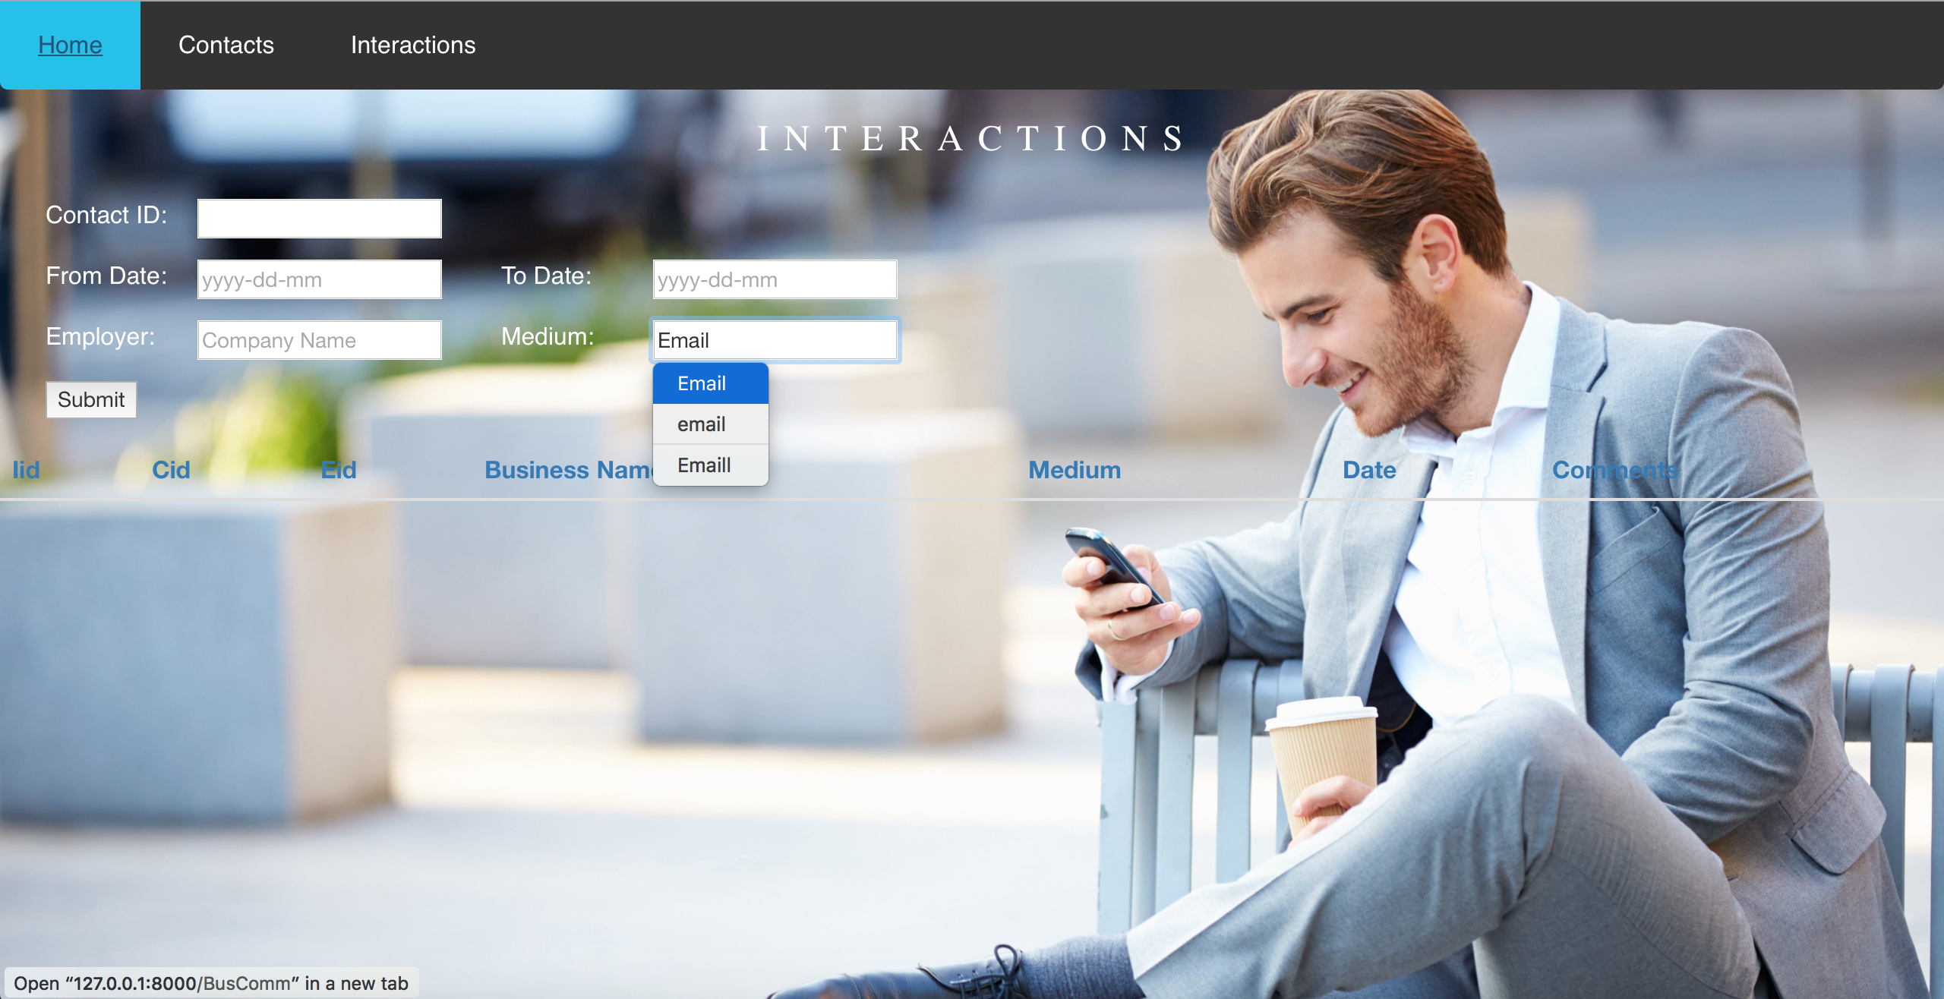

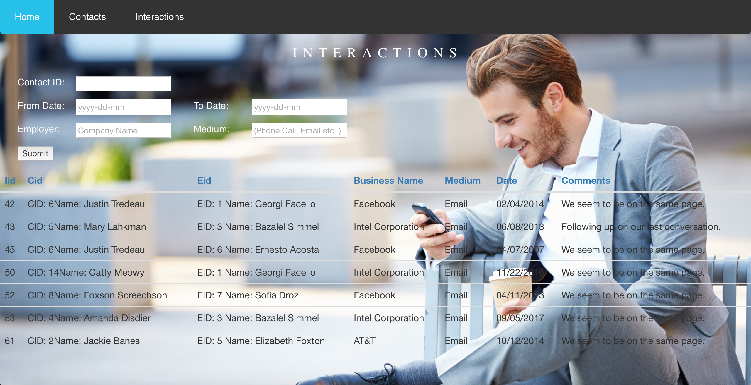

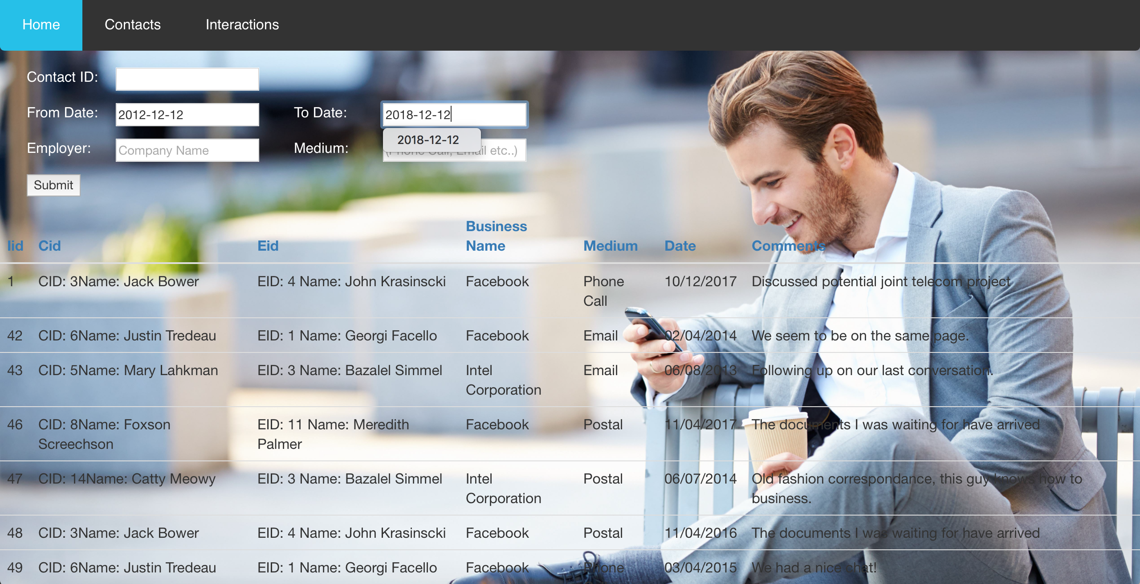

**Note:**

Obviously the front end could use a better design, but I’m not a designer. As for the forms in the Contacts and Interactions pages, they are combination-enabled, meaning that you can pick and choose what data combo you need and requested from the DB, as you saw me do in a couple of examples.

This enables searching for any and all data. I was, however, unable to finish the front end, as other assignments require my attention. But other things I would’ve like to include was form inputs for *Job Title*, *EID* and *Manager*, to enable searching by position, the contacting employee, and by superior (which would enable a user to identify a contacts subordinates). All of these queries are already possible in the database, fully functioning. But I would’ve like to include front end resources to request that data.

An example of a search by superior, to identify subordinates operates as follows in the DB,

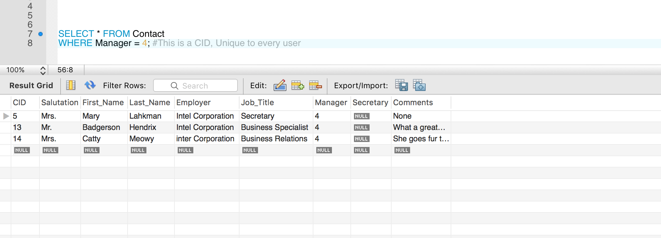

Inversely we can search for a contacts supervisor (If we have their info in our DB) as follows,

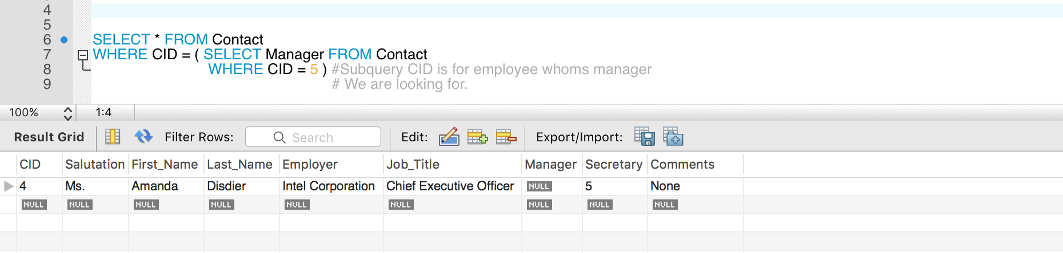

Searching for contacts with more than 3 interactions,

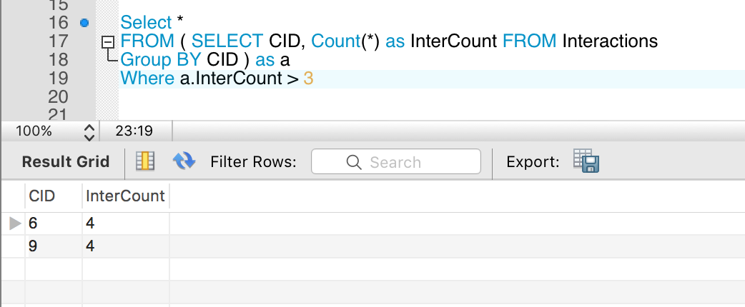

Searching for all contacts with a home address listed for a particular city,

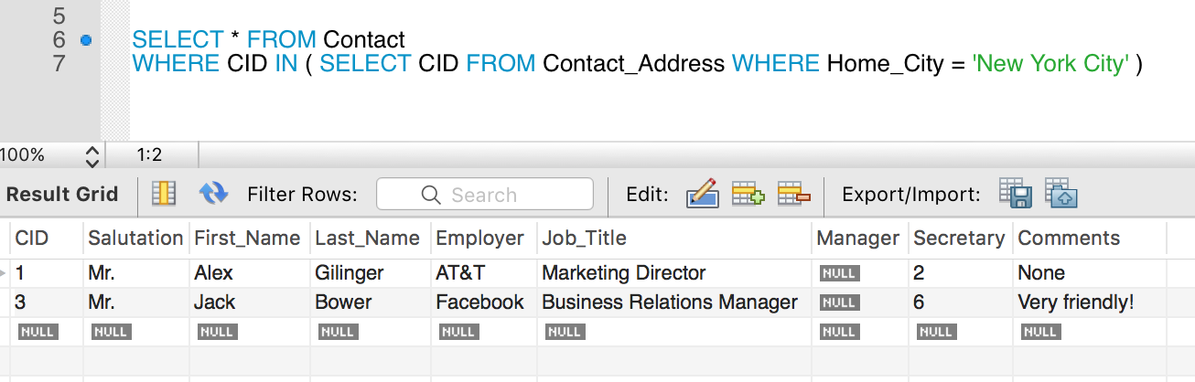

List number of contacts per company is descending order. This search is already possible through the front end, but the ordering feature has not been implemented.

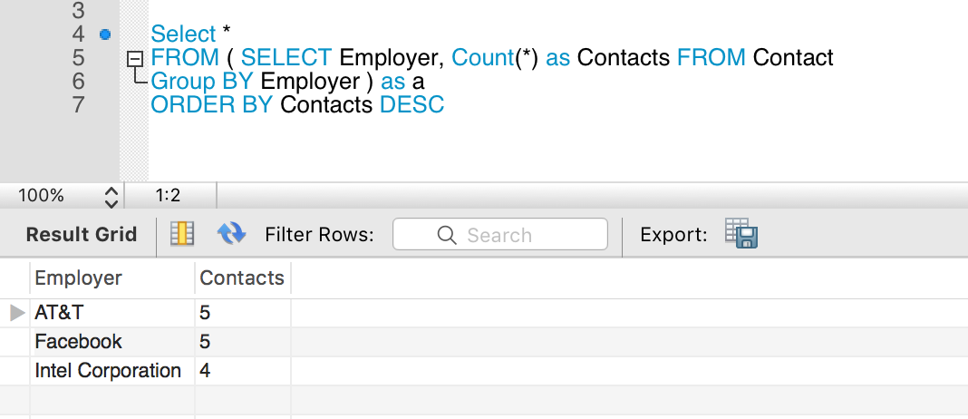

**Database functionality:**The database itself is fully functional and works perfectly to provide all data necessary as requested of the assignment. The front-end app however, has not been completed and patched, but still looks nice and was n interesting and learning experience using Django to deploy it.